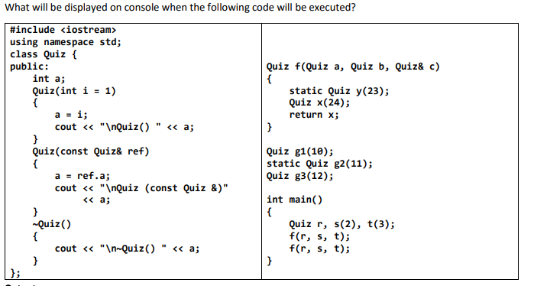
The output of said program is given below along with explanation:

Quiz() 10 - Control of code execution will start from the first function call, in this case it is “g1”, with given output <-
Quiz() 11 - Static object of “g2” is initialized, with given output <-
Quiz() 12 - “g3” is then initialized, with given output <-
Quiz() 1 - Control now goes in main function and “r” is initialized, with no parameters, it will then initialize with default parameter a = 1, with given output <-
Quiz() 2 - “s” is initialized, with given output <-
Quiz() 3 - “t” is initialized, with given output <-
Quiz (const Quiz &)2
- “f” function is called and it takes first 2 objects by value and last object by reference, by value calls, will call the copy constructor which will run from right to left in parameters list, leading to copy call for 2nd object first, with given output ^^

Quiz (const Quiz &)1
- Copy call for 1st object in parameter list, with given output <-
Quiz() 23 - Static object of “y” is initialized, with given output <-
Quiz() 24 - “x” is initialized, with given output <-
Quiz (const Quiz &)24
- In return call of “x” the copy constructor is called, with given output ^^
~Quiz() 24 - Destructor will be called for “x” in the function “f”, with given output <-
~Quiz() 1 - Destructor is called for the copy of the 1st object in the parameter list, here we can see that copies are destroyed from left to right of the parameter list, with given output <-
~Quiz() 2 - Destructor is called for the copy of the 2nd object in the parameter list, here we can see that the 3rd parameter is left as it was passed by reference and its copy was not called, with given output <-
~Quiz() 24 - Destructor is called for the copy of the , with given output <-
// This last function call will have identical code execution, except for the static object “y Quiz(23)” as it will be handled in the end of program.
Quiz (const Quiz &)2
Quiz (const Quiz &)1
Quiz() 24
Quiz (const Quiz &)24
~Quiz() 24
~Quiz() 1
~Quiz() 2
~Quiz() 24
~Quiz() 3 - Destructor called for last made object in main’s scope “t”
~Quiz() 2 - Destructor called for 2nd last made object “s” with given output <-
~Quiz() 1 - Destructor called for 1st made object “r”, with given output <-
~Quiz() 23 - Now Destructor will be called for static objects in main’s scope, this time for “y”, with given output <-
~Quiz() 12 - Now Destructor will be called for objects made globally this time for 3rd last “g3”, with given output <-
~Quiz() 11 - Destructor called for 2nd last global object “g2”, with given output <-
~Quiz() 10 - Destructor called for 1st global object “g1”, with given output <-

